Custom Training

Day 22

**DevOps**

Builds the gap between development and operations.

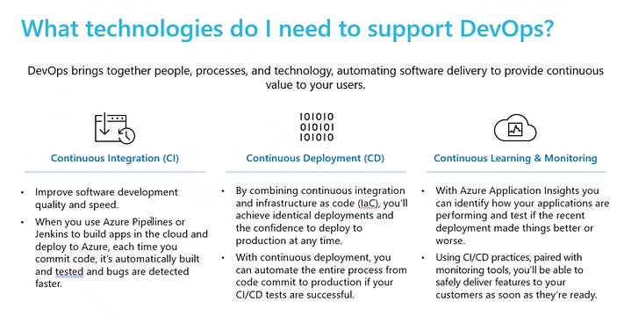

Azure DevOps:

Azure Boards: To track the cost and progress of the project.

Epic: Large body of work in project.

Feature: Detailed logical breakdown of an epic.

User Story: Further breakdown of feature. It will be time-bounded.

Sprint: Goal-oriented and time-bounded process. Usually 15 days is one sprint.

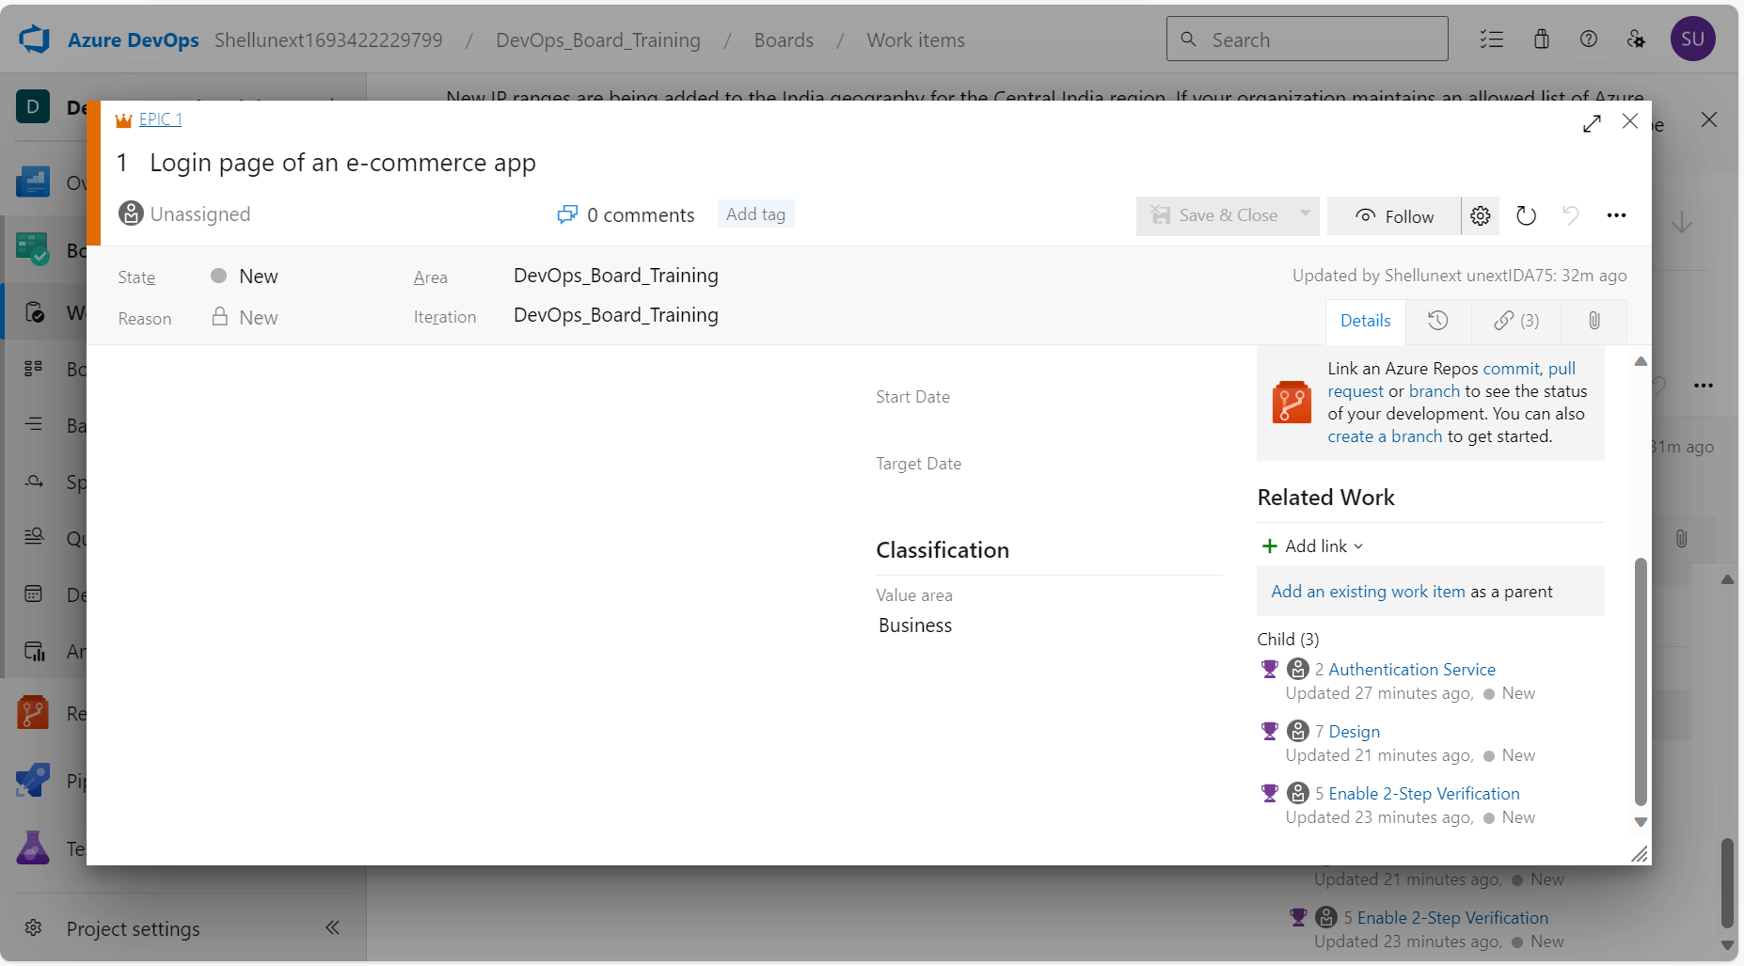

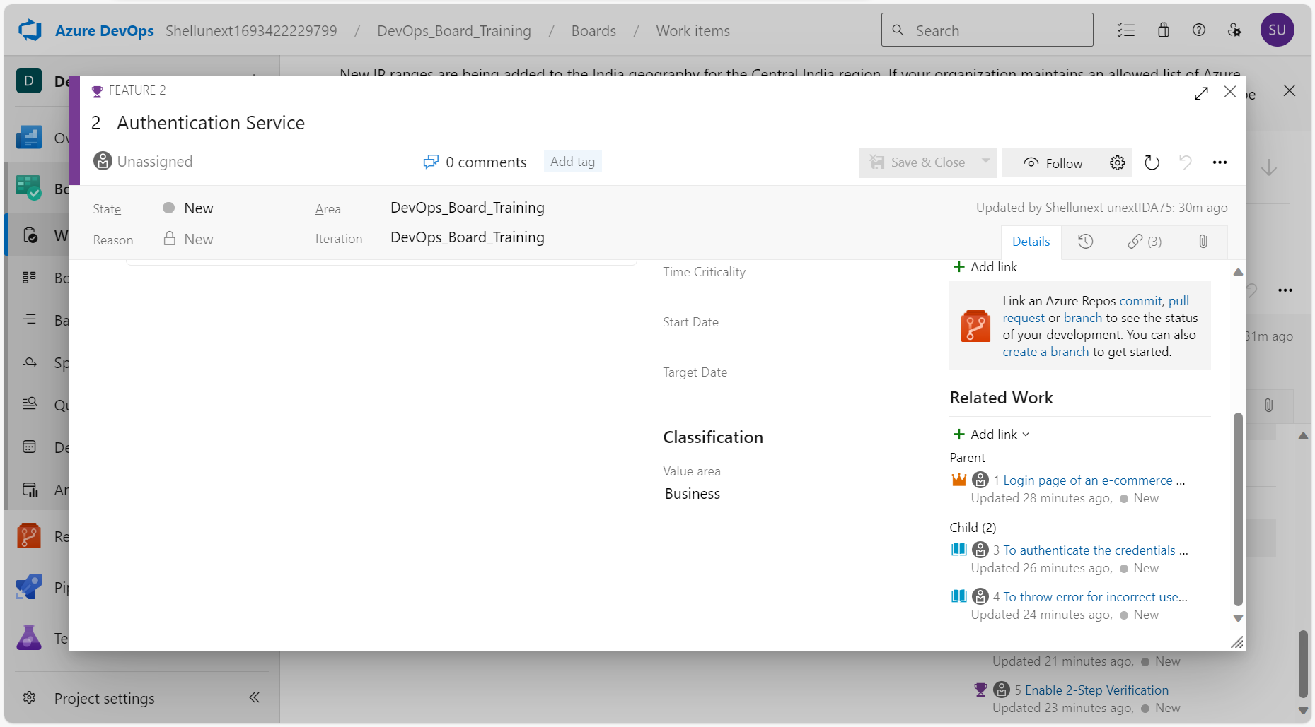

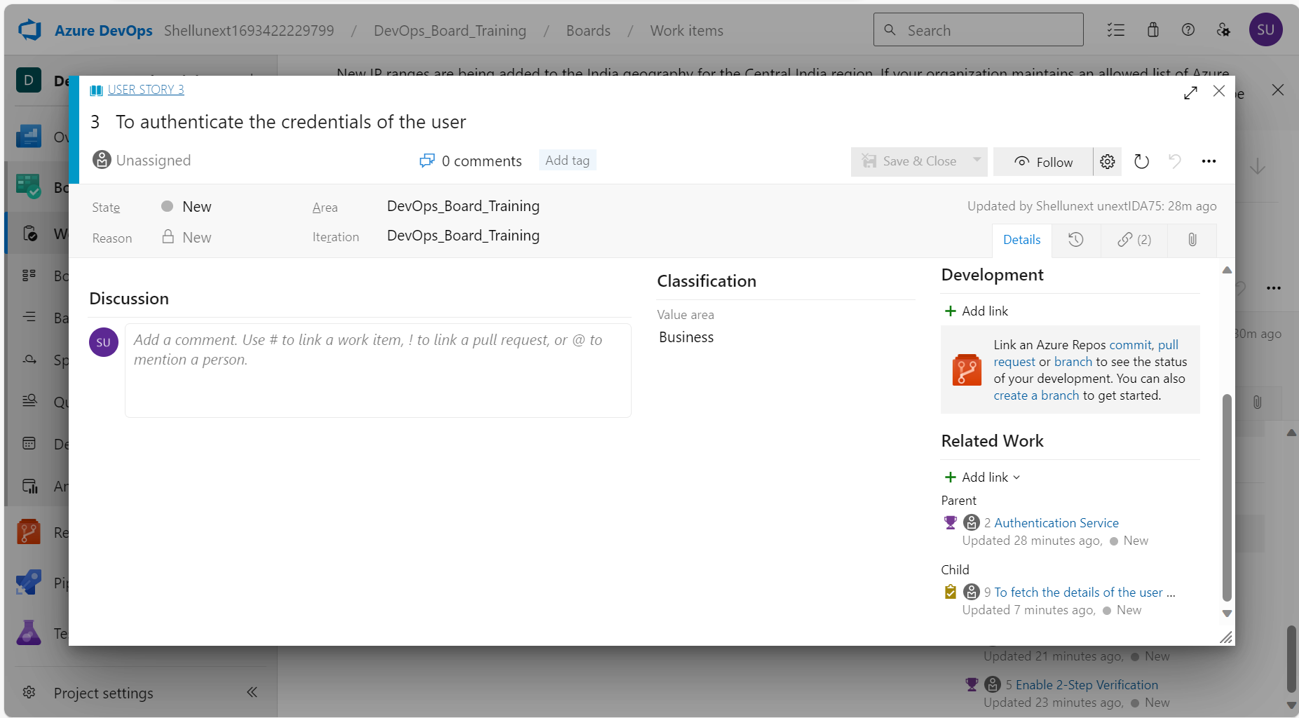

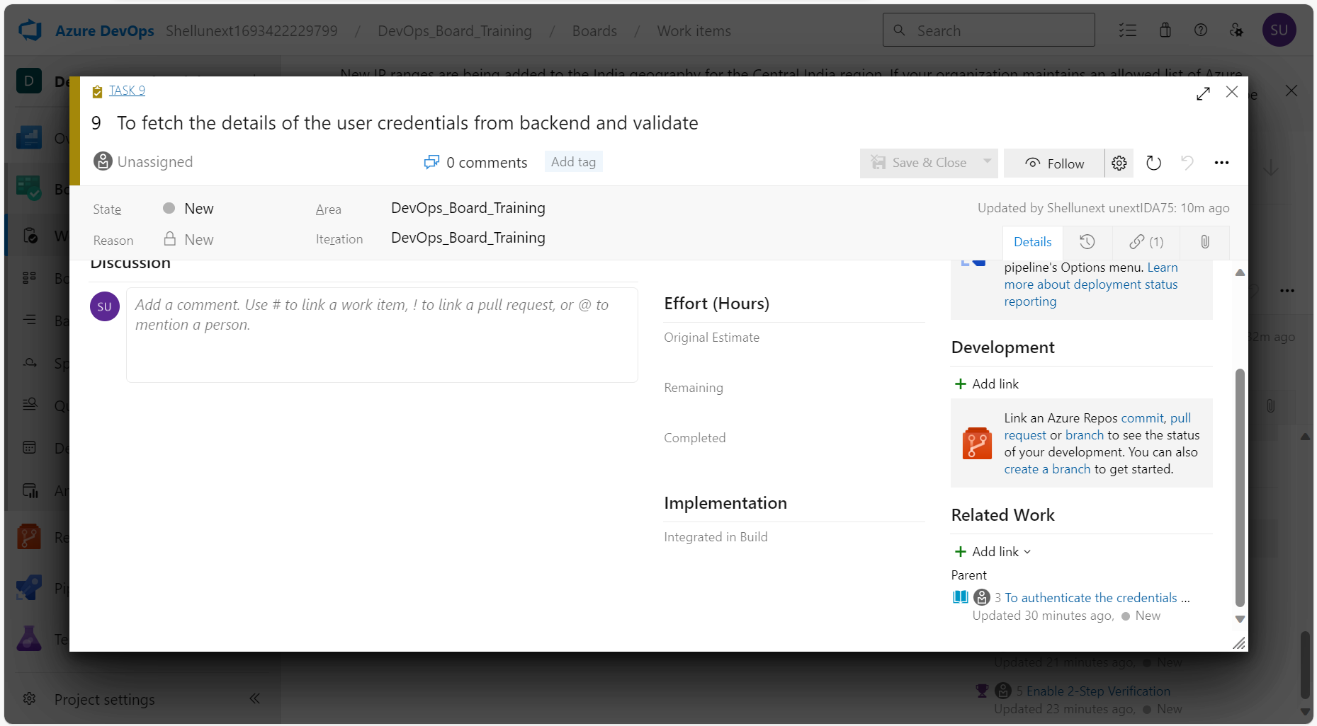

Acceptance Criteria: Based on the acceptance criteria conditions, the user story will be accepted otherwise if not fulfilled, the user story will be rejected.

Repos: Where we can store and track our source code.

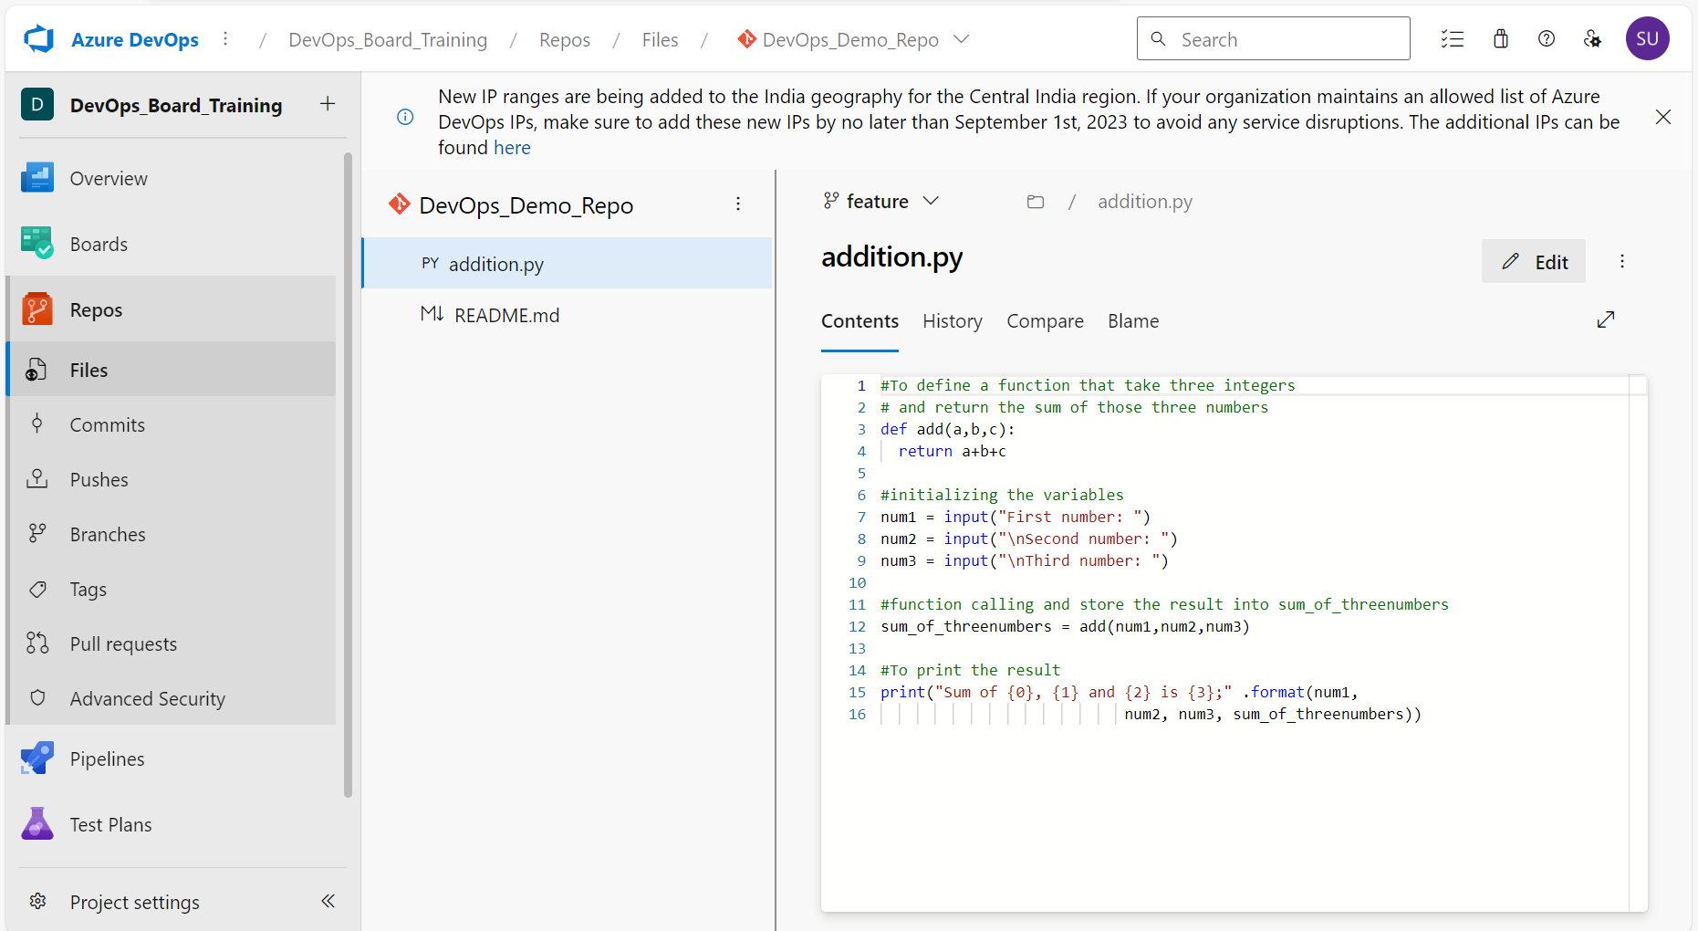

The pull request details after completing the pull request:

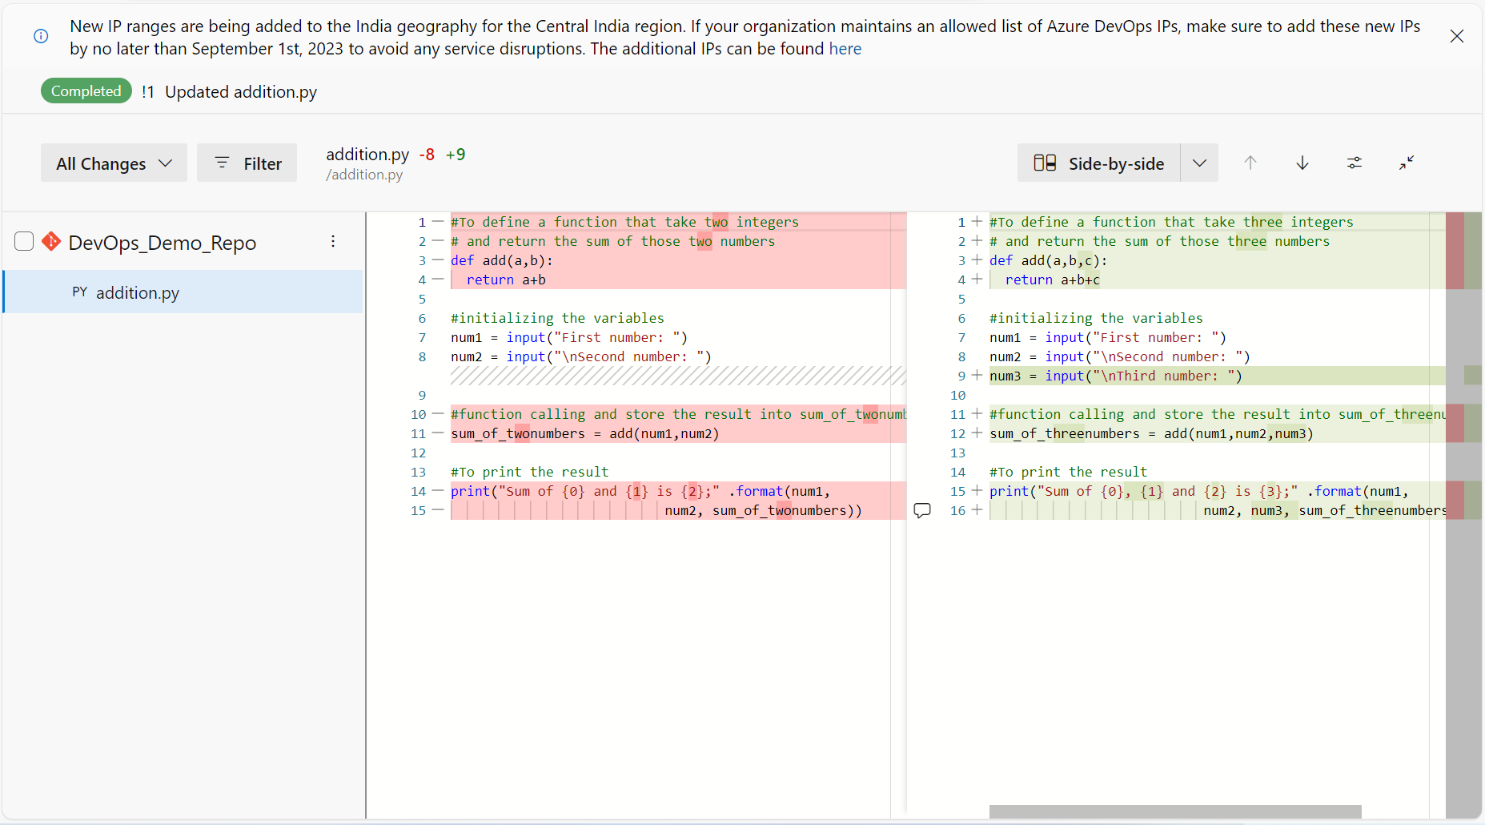

After merging with the main branch:

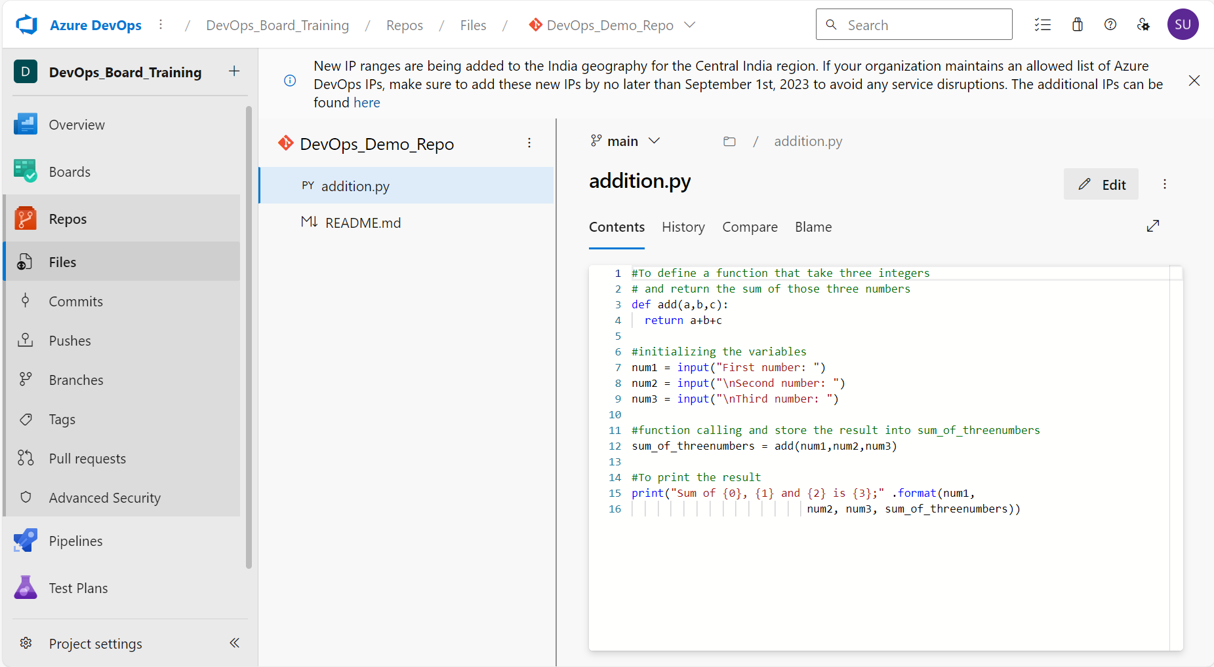

Pipeline: To create our own pipeline to take the source code from a repo and test it the next second.

Scenario:

* + Main branch is present
  + To work on the code changes, a feature branch is also present
  + Upon making changes, pull request is done
  + The main branch is updated using merge
  + To automate the process of continuous deployment, a pipeline is created
  + The continuous deployment ensures that the testing process happens with integration

Inside the pipeline

* The trigger suggests that when any changes are made in the main branch, the pipeline should start running
* Create the pipeline with the Flask project in GitHub and then save and run
* Python Flask 3.7 application is running

